🔑 API Key Setup Guide (All Providers)
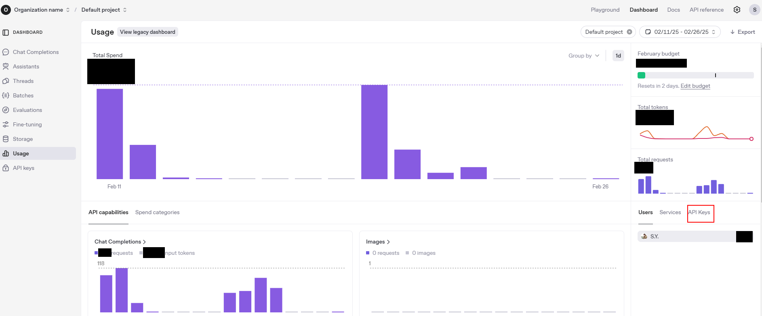
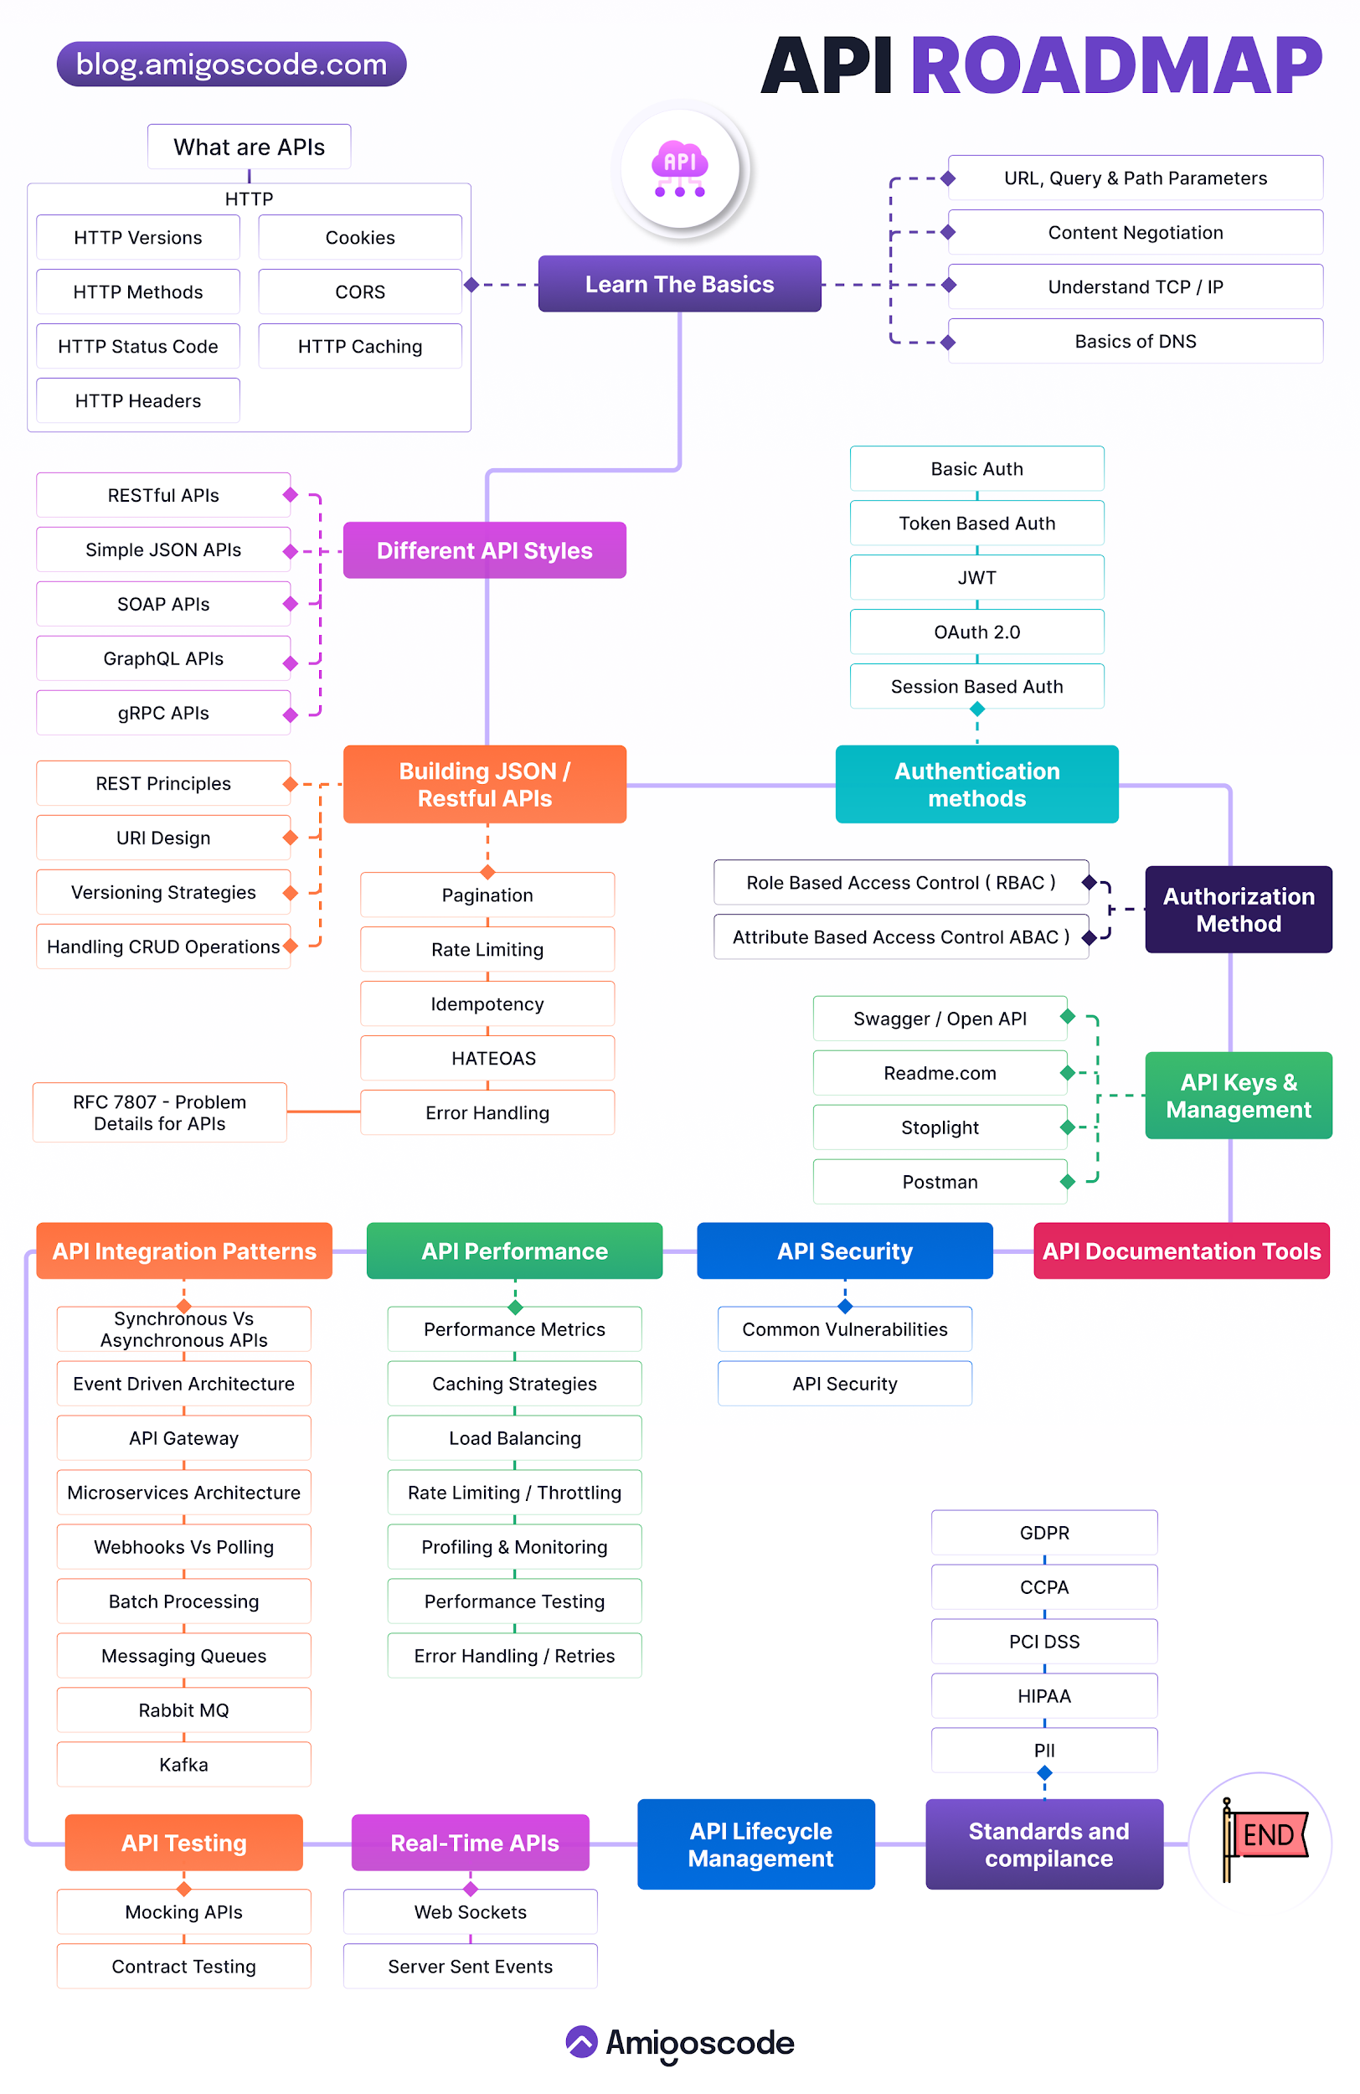
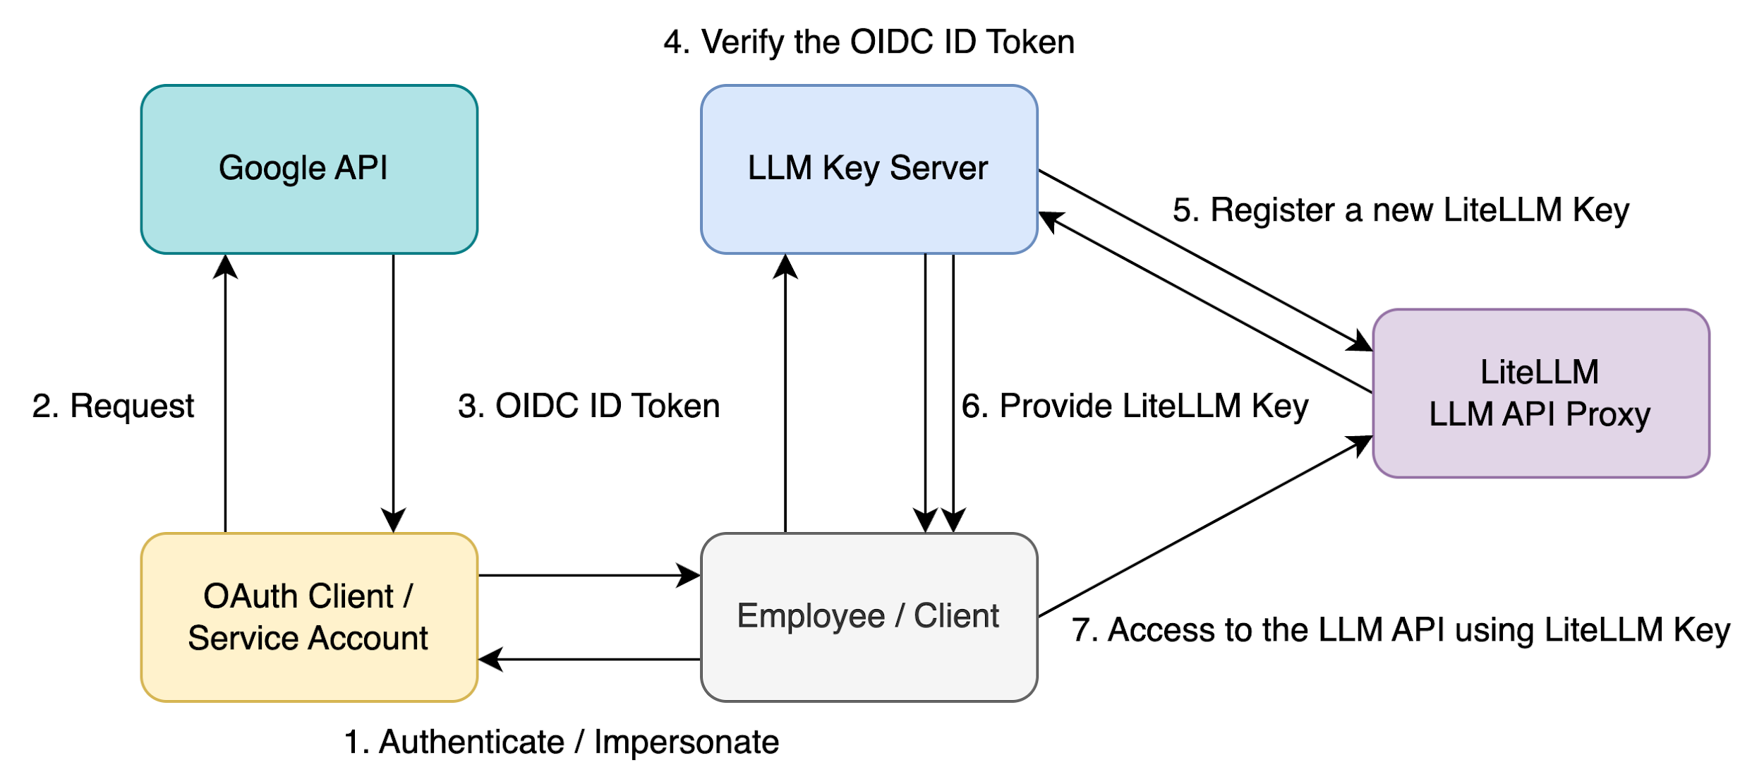

🟢 1. Hugging Face (FREE – Best for Demos)

Provider
Hugging Face

Cost
✅ FREE tier available (no credit card)

Steps
- Open 👉 https://huggingface.co
- Sign up / Login
- Click Profile picture → Settings
- Go to Access Tokens
- Click New token
- Name: demo-token
- Role: Read
- Click Generate
- Copy token → save securely

Use in Code
HF_TOKEN = "hf_xxxxxxxxxxxxxxxxx"

✅ Works for Mistral, Qwen, Falcon (small), LLaMA variants

🟢 2. Google Gemini (FREE Tier)

Provider
Google

Cost
✅ FREE tier (very generous)
❌ Credit card NOT required for demos

Steps
- Open 👉 https://aistudio.google.com
- Login with Google account
- Click Get API Key
- Choose Create API key
- Copy key

Use in Code
GEMINI_API_KEY = "AIzaSyxxxxxxxxxxxx"

✅ Best for education, fast demos, multimodal

🟢 3. OpenRouter (FREE Quota)

Provider
OpenRouter

Cost
✅ Free credits available
⚠️ Paid after quota (optional)

Steps
- Open 👉 https://openrouter.ai
- Sign up
- Go to Dashboard → API Keys
- Click Create Key
- Copy key

Use in Code
OPENROUTER_API_KEY = "sk-or-xxxxxxxxxx"

✅ One API → many models
✅ Excellent for model comparison

⚠️ 4. ChatGPT / OpenAI (Free Credits Only)

Provider
OpenAI

Cost
⚠️ Not fully free
✅ Free credits on signup

Steps
- Open 👉 https://platform.openai.com
- Login / Signup
- Go to View API keys
- Click Create new secret key
- Copy key (shown once)

Use in Code
OPENAI_API_KEY = "sk-xxxxxxxxxxxx"

💡 Use gpt-4o-mini for cheapest demos

⚠️ 5. Claude (Anthropic – Trial Credits)

Provider
Anthropic

Cost
⚠️ Trial credits sometimes available

Steps
- Open 👉 https://console.anthropic.com
- Signup / Login
- Go to API Keys
- Click Create Key
- Copy key

Use in Code
ANTHROPIC_API_KEY = "sk-ant-xxxxxxxxxx"

✅ Best for long documents, legal, policy

🏠 BONUS: Ollama (NO API Key Needed)

Provider
Ollama

Cost
✅ 100% FREE
✅ Offline
✅ Private

Steps
- Install 👉 https://ollama.com/download
Run:
ollama pull mistral
ollama pull llama2
ollama pull qwen

Ollama runs at:
http://localhost:11434

❌ No API key required
✔ Best for government, HR, healthcare

📊 Quick Comparison Table
Provider | Free? | Credit Card | Best For
Hugging Face | ✅ Yes | ❌ No | Open-source demos
Gemini | ✅ Yes | ❌ No | Education
OpenRouter | ✅ Limited | ❌ No | Multi-model
ChatGPT | ⚠️ Credits | ✅ Yes | Reasoning
Claude | ⚠️ Trial | ❓ Sometimes | Long docs
Ollama | ✅ Yes | ❌ No | Private AI

🎤 One-Line Explanation (Interview-Ready)
“For demos, I use Hugging Face, Gemini, and OpenRouter because they offer free API access. For sensitive data, I use Ollama locally, which needs no API key.”

✅ Recommended Setup for YOU (Zero Cost)
Hugging Face → Open-source LLMs
Gemini → Big-tech AI
OpenRouter → Multi-model comparison
Ollama → Private AI

This combo makes your demo very strong 💯

🚀 Want Next?
I can now:
- 🔄 Add Gradio UI to this single notebook
- 📊 Add side-by-side response comparison
- 📄 Add RAG (PDF → answer)
- 📘 Convert all this into a PDF teaching handbook
Just tell me next step 👨‍🏫🔥
Got it 👍
Below are CLEAR, STEP-BY-STEP API KEY SETUP + USAGE instructions for Grok (xAI) and Claude (Anthropic) — written for demo + teaching + interviews.

🔑 Grok & Claude — API Setup + Demo Usage
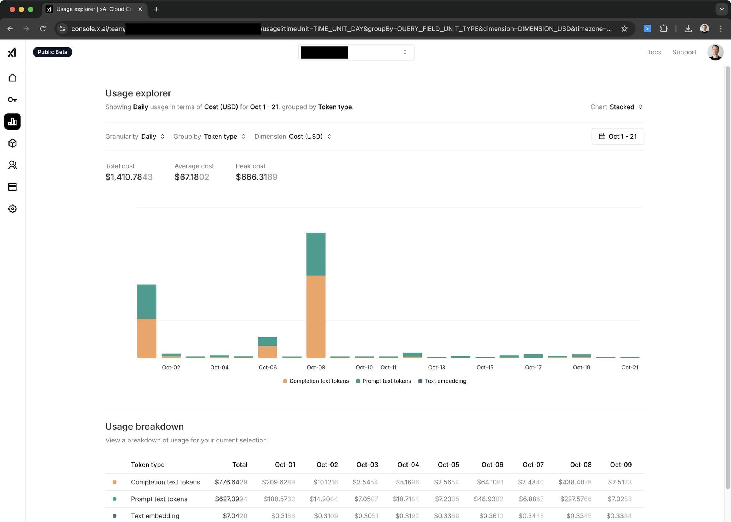
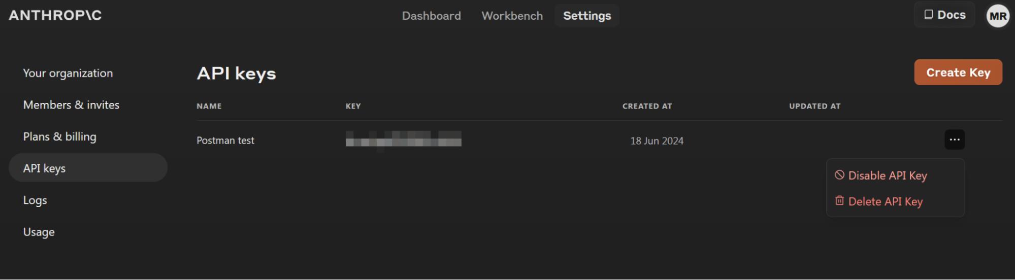
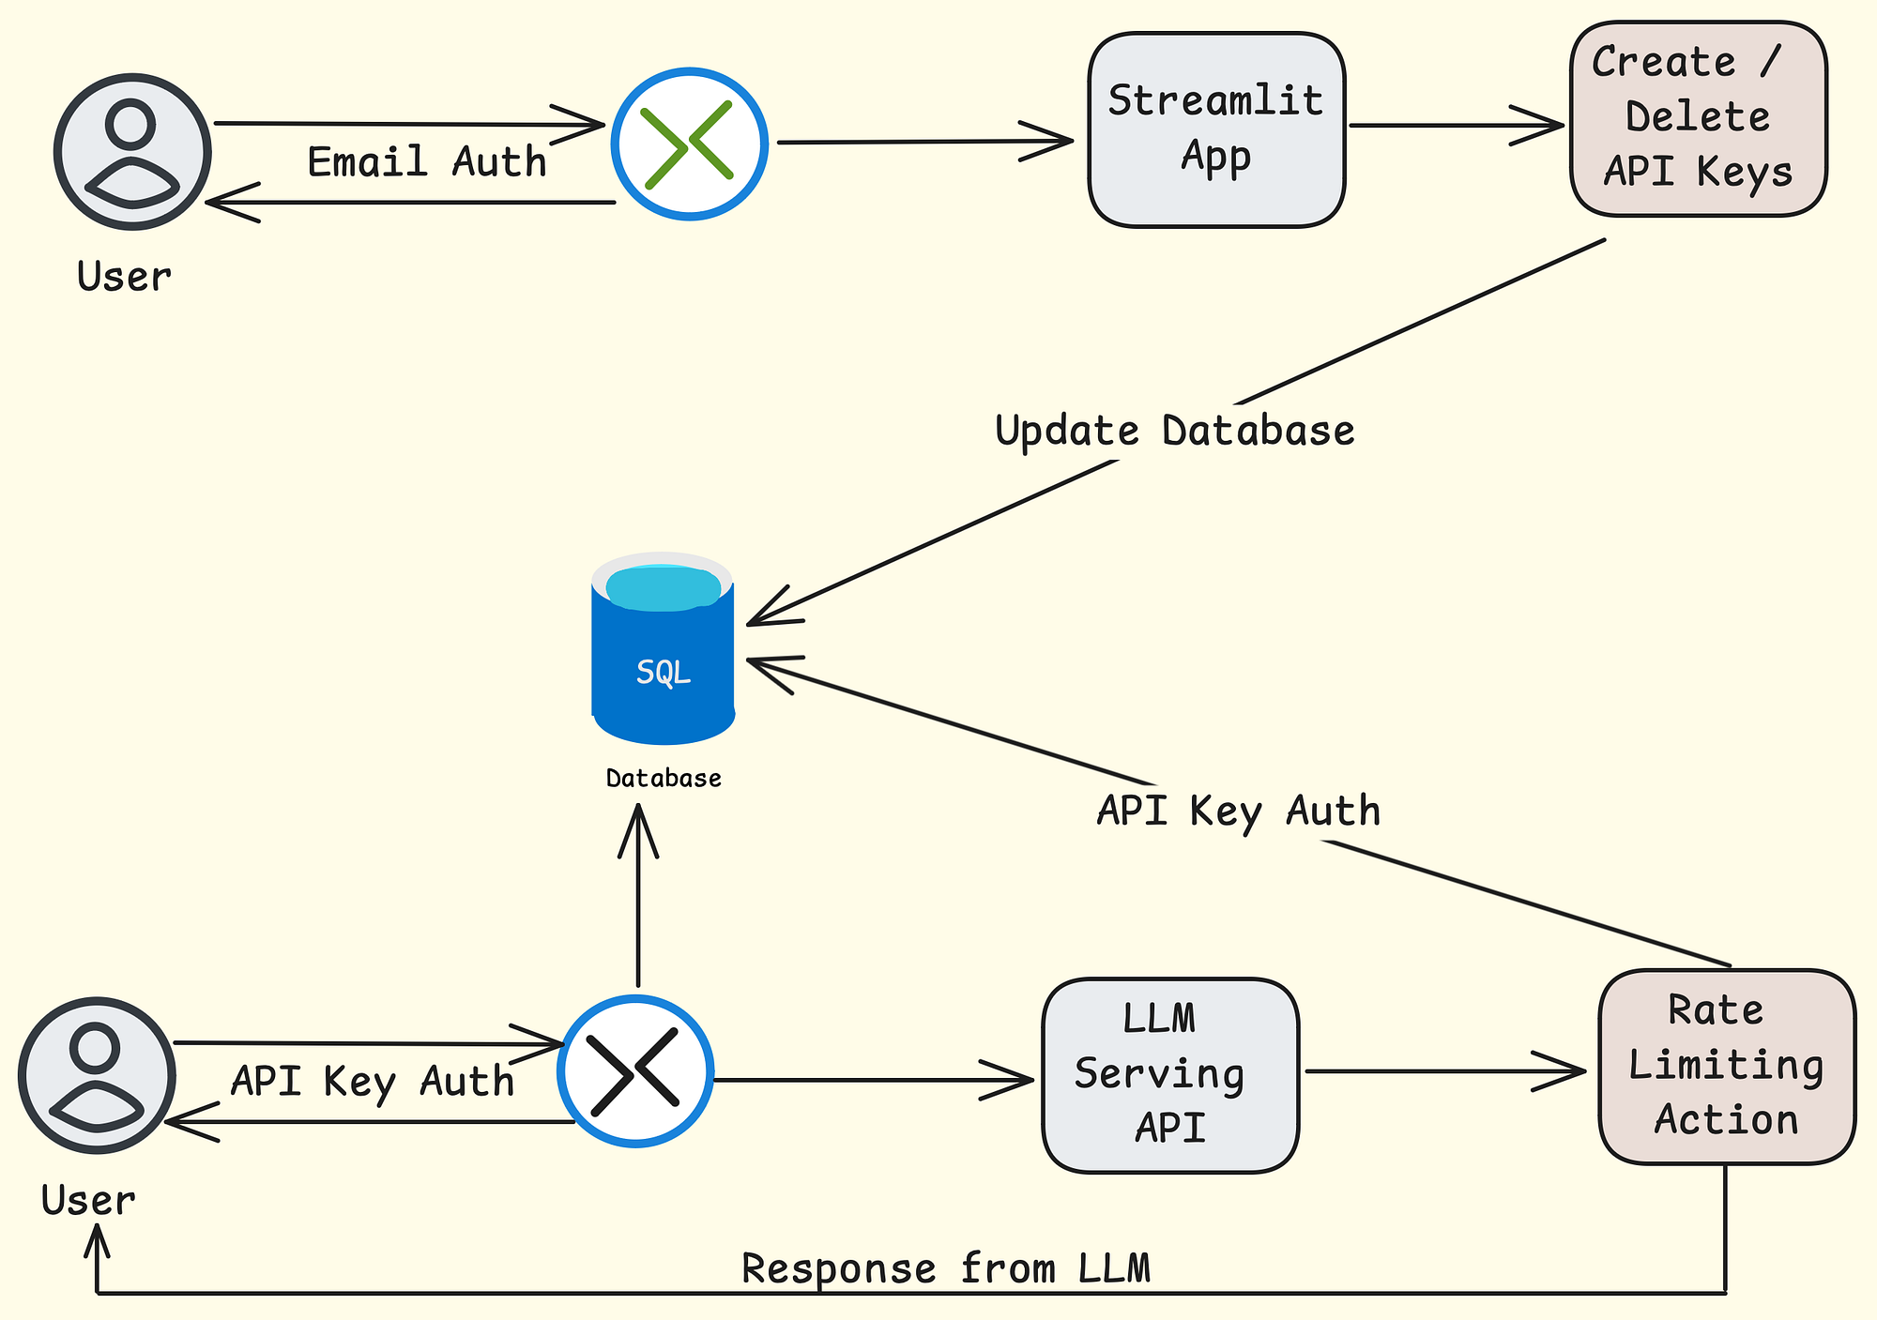

🟣 1. Grok API (xAI)

Provider
xAI

What is Grok?
- LLM created by Elon Musk’s xAI
- Strong in:
  - Real-time information
  - Trends
  - Opinionated answers
  - Social/X-related data

💰 Cost / Free Access (Important)
- ⚠️ No permanent free tier
- ✅ Free / trial access sometimes available
- Often bundled with:
  - X (Twitter) developer programs
  - Promotional API credits
👉 Best for demos when trial is active

🪜 Steps to Create Grok API Key
- Open 👉 https://console.x.ai
- Sign in using X (Twitter) account
- Go to API / Developer Dashboard
- Click Create API Key
- Copy the key (shown once)
📌 API base URL:
https://api.x.ai/v1

🧪 Python Demo Code (Grok API)
import requests

GROK_API_KEY = "YOUR_GROK_API_KEY"

response = requests.post(
"https://api.x.ai/v1/chat/completions",
headers={
"Authorization": f"Bearer {GROK_API_KEY}",
"Content-Type": "application/json"
},
json={
"model": "grok-beta",
"messages": [
{"role": "user", "content": "What are today's AI trends?"}
]
}
)

print(response.json()["choices"][0]["message"]["content"])

✅ When to Use Grok
Scenario | Use Grok?
Trend analysis | ✅
Social media insights | ✅
News-aware chatbot | ✅
HR / Legal data | ❌

🔵 2. Claude API (Anthropic)

Provider
Anthropic

What is Claude?
- Designed for safe, reliable, long-context reasoning
- Excellent for:
  - Legal documents
  - Policy analysis
  - HR compliance
  - Government usage

💰 Cost / Free Access (Important)
- ⚠️ No permanent free tier
- ✅ Trial credits sometimes provided
- ❌ Credit card may be required after trial
👉 Very strong for enterprise demos

🪜 Steps to Create Claude API Key
- Open 👉 https://console.anthropic.com
- Sign up / Login
- Go to API Keys
- Click Create Key
- Copy key (shown once)
📌 API base URL:
https://api.anthropic.com

🧪 Python Demo Code (Claude API)
import anthropic

ANTHROPIC_API_KEY = "YOUR_ANTHROPIC_API_KEY"

client = anthropic.Anthropic(api_key=ANTHROPIC_API_KEY)

message = client.messages.create(
model="claude-3-haiku-20240307",
max_tokens=300,
messages=[
{
"role": "user",
"content": "Summarize this government policy in simple language"
}
]
)

print(message.content[0].text)

✅ When to Use Claude
Scenario | Use Claude?
Long documents | ✅
Legal / HR | ✅
Government policies | ✅
Fast chat | ❌

⚖️ Grok vs Claude (Quick Comparison)
Feature | Grok | Claude
Real-time info | ✅ | ❌
Long context | ❌ | ✅
Safety & compliance | ❌ | ✅
Free tier | ❌ | ❌
Best demo use | Trends | Policy

🏆 Honest Recommendation for Demos (ZERO / LOW COST)
Purpose | Best Option
Free demo | Hugging Face / Gemini
Private demo | Ollama
Trend demo | Grok (trial)
Policy demo | Claude (trial)
👉 Do NOT rely on Grok / Claude for free workshops
👉 Use them as premium comparison models

🎤 Interview-Ready One-Line Answer
“Claude is designed for safe, long-context enterprise use cases like legal and policy analysis, while Grok focuses on real-time and social data. Both are premium APIs, unlike open-source or Gemini which offer free demo access.”

🚀 Want Next?
I can:
- 🔄 Add Grok & Claude into your single notebook router
- 📊 Create cost comparison table
- 🧠 Build LLM auto-router (FastAPI)
- 📘 Convert this into PDF teaching slides
Just tell me next step 👨‍🏫🔥

